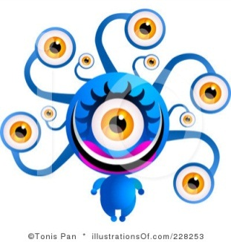vead

vaid

emper



shurb

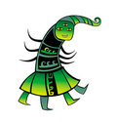 muew



rowpt

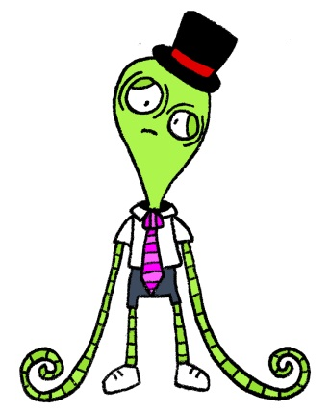doiz

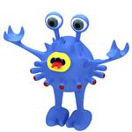

jawnd

splare

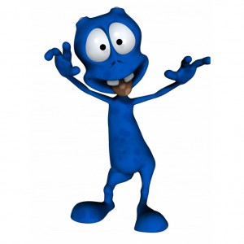

scrobe

oskire

[](http://www.google.co.uk/imgres?start=99&hl=en&sa=X&gbv=2&biw=1167&bih=594&addh=36&tbs=ic:color,itp:clipart&tbm=isch&tbnid=dsuaJm5w-Fl7xM:&imgrefurl=http://www.clipartof.com/portfolio/a-papantoniou/illustration/friendly-blue-alien-with-spiky-green-hair-and-big-green-eyes-looking-upwards-and-waving-20367.html&docid=GIiTSsKm55Gv9M&imgurl=http://images.clipartof.com/small/20367-Clipart-Illustration-Of-A-Friendly-Blue-Alien-With-Spiky-Green-Hair-And-Big-Green-Eyes-Looking-Upwards-And-Waving.jpg&w=385&h=450&ei=vkedT4LmN4nD0QXtqIj4Dg&zoom=1&iact=hc&vpx=256&vpy=201&dur=73&hovh=243&hovw=208&tx=80&ty=235&sig=106041830873671471080&page=5&tbnh=133&tbnw=114&ndsp=29&ved=1t:429,r:1,s:99,i:7)

quoap

srite



snemp

sprane

[](http://www.google.co.uk/imgres?hl=en&sa=X&gbv=2&biw=1167&bih=594&tbs=ic:color,itp:clipart&tbm=isch&tbnid=3eAPhHaVPrqbSM:&imgrefurl=http://mrlamebutt.blogspot.com/2010/12/i-had-dream-last-night.html&docid=qUtnxBAw-H8nwM&imgurl=http://1.bp.blogspot.com/_EPY9uCS8E0A/TRjjDAZh8nI/AAAAAAAAAC0/8BdZ2OB2x8w/s1600/231294073_1cdb6ad422.jpg&w=400&h=500&ei=PkedT47kMcn80QWTr-nmDg&zoom=1&iact=hc&vpx=609&vpy=113&dur=713&hovh=251&hovw=201&tx=111&ty=156&sig=106041830873671471080&page=3&tbnh=129&tbnw=103&start=43&ndsp=28&ved=1t:429,r:4,s:43,i:254)terg

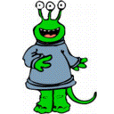fape

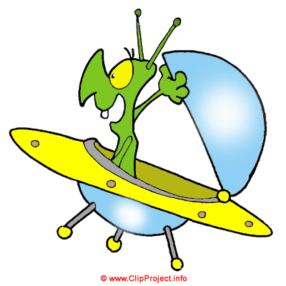haid

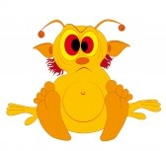

chume

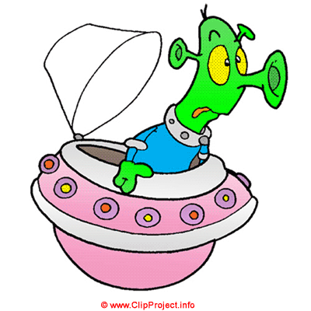goik

boat

finger

brown

shake

please

square

hamster

throat

conspire

weather

bonfire

slurp

spear

plain

phone

excuse

better

newt

slurp

toast