Musical Instruments (Strumenti musicali)

Print (or write out) the activities on the next pages. Activities get harder with each page just try as many of the pages as you can. Afterwards, see how many words you can remember, revise and try to learn the new vocabulary.

As a guide:

Year 1 pupils, Try the activities on pages 1 to 3
Year 2 pupils, Try the activities on pages 1 to 4.
Year 3 pupils, Try the activities on pages 1 to 5
Year 4 pupils, Try the activities on pages 1 to 6
Year 5 and 6 pupils, try the activities on all the pages.

- Listen to the song on the following link. Learn the names of the musical instruments in the video and repeat them. Below are the names that you should have learnt in the video.
https://www.youtube.com/watch?v=W7RSDeSz8DU

Arpa

Flauto

Timpani

Pianoforte

Fisarmonica

Nacchere

Violino

Tamburi

Chitazza

Fagotto

Tromba

Organo

Maracas

Oboe

Grancassa

Corno

Trombone

Cembali

Voce

Clarinetto

Cornamusa

Xilofono

Gong

triangolo

Colour the pictures below and translate the name of the musical instrument from Italian to English.

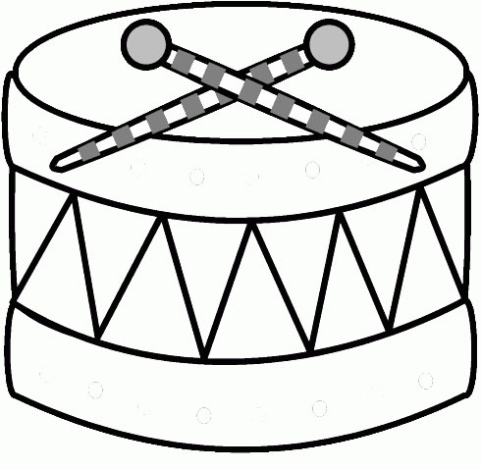  il tamburo | 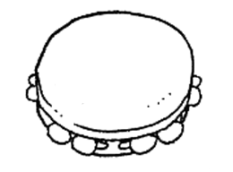  il tamburello | 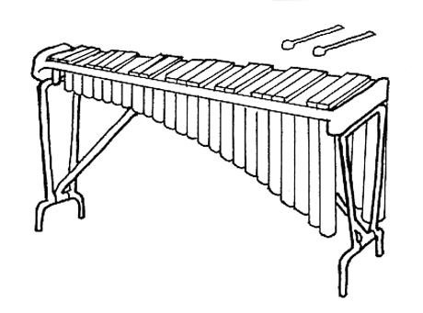  lo xilofono
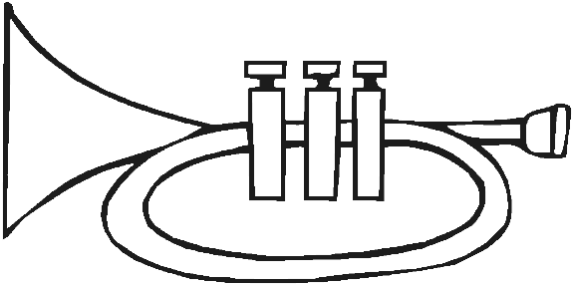  la tromba | 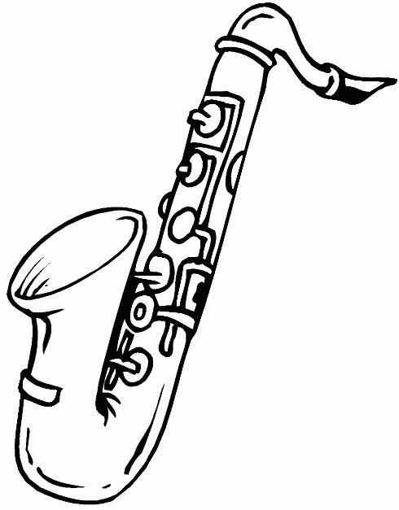  il sassofono | 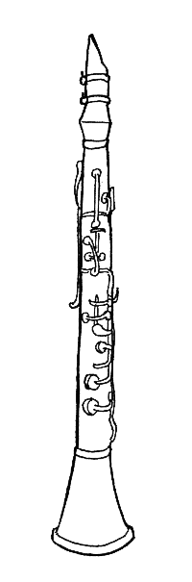  il clarinetto | 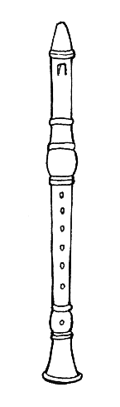  il flauto
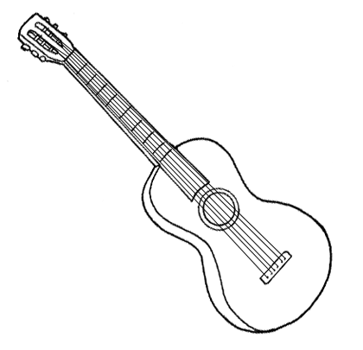  la chitarra | 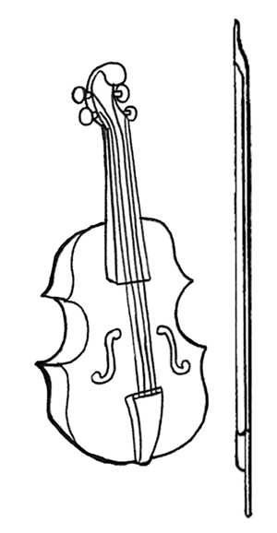  il violino | 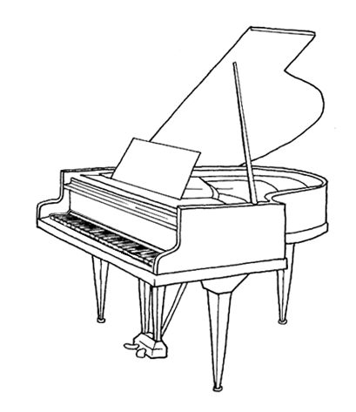  il pianoforte | 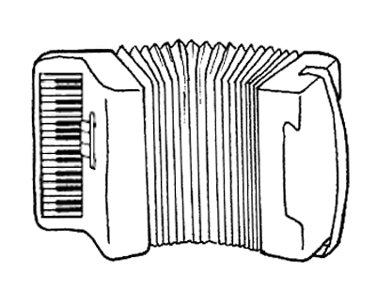  la fisarmonica

- Complete the wordsearch below by finding the Italian names for the musical instruments from page 2

t | a | m | b | u | r | e | l | l | o | o
c | h | i | t | a | r | r | a | x | t | r
p | i | a | n | o | f | o | r | t | e | l
f | l | a | u | t | o | s | e | b | t | s
t | r | o | m | b | a | n | m | e | f | i
u | b | n | t | v | i | o | l | i | n | o
f | i | s | a | r | m | o | n | i | c | a
u | i | t | a | m | b | u | r | o | z | u
r | x | l | x | i | l | o | f | o | n | o
w | c | s | a | s | s | o | f | o | n | o

- Complete the crossword in Italian using the clues in the pictures.

 | 3 | 9
   |  |  |  |  |  |  |  |  |  | 1
   |  |  | 2
   |  |  |  |  | 3
   |  |  |  |  |  |  |  | 4
   |  |  |  |  |  | 5
   |  |  |  |  | 6
   |  |  | 7 |  |  |  |  |  |  |  | 8
   |  | 9
   | 10
  11
 | 8 | 10
 | 7 | 6
 | 5 | 4
 | 1 | 2
 | 11
- Cut out the pictures, paste them into your note books and complete the phases with the verb ‘suona’. For example Paolo suona la tromba (Paolo plays the trumpet).

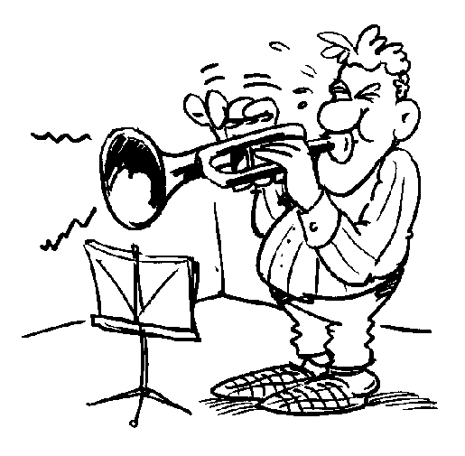  Paolo suona la tromba. | 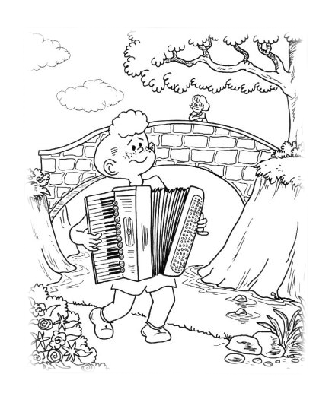  Angelo | 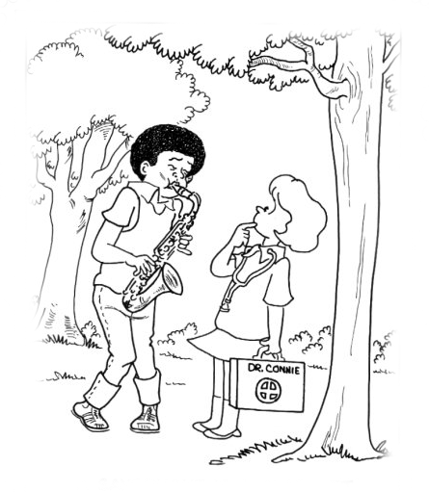  Erminio | 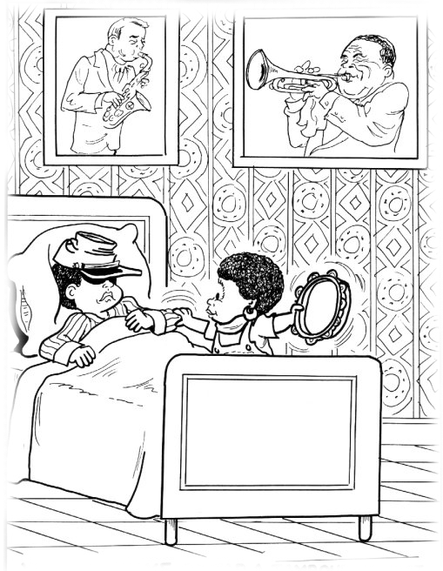  Marta
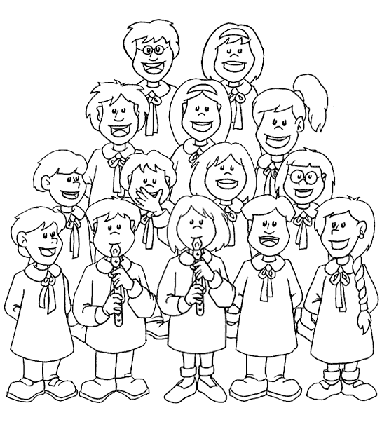 | 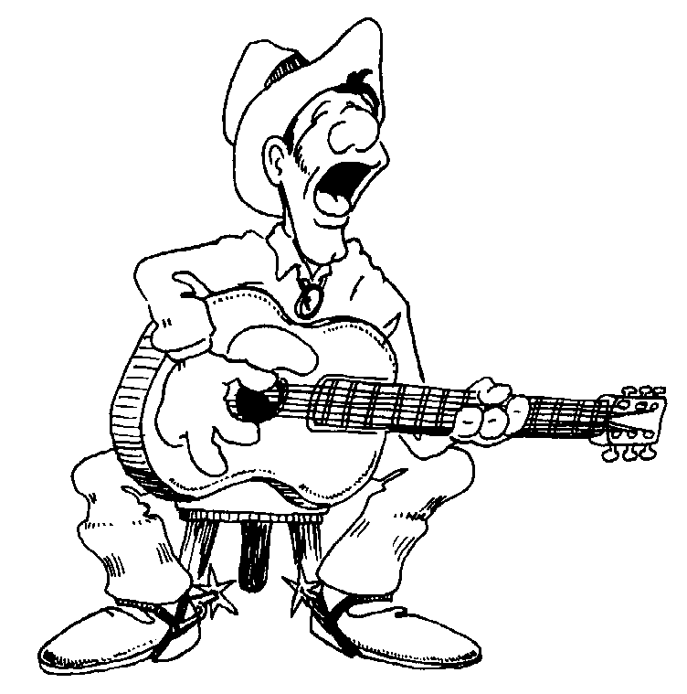 | 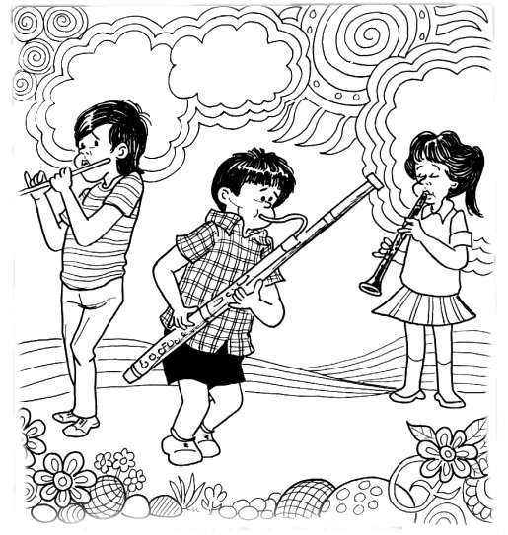 | 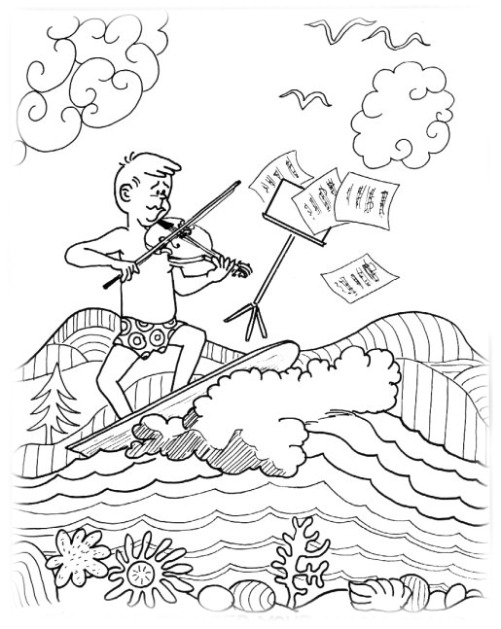
Lisa Alberto Gianna Claudio
- Complete the phases. For example io suono la chitarra (I play the guitar)

Io suono.........

Io suono.........

Io suono.........

Io suono.........

Io suono.........

